**Sprint 2 Retrospective**

|  |  |
| --- | --- |
| Student No | Name |
| 09469010 | Zaine Ashe |
| 09592059 | Xuesen Li |
| 09617019 | Blue Lan |
| 09677542 | Evan Zhang |
| 09727655 | Asuka Van Den Hooven |

Unit: IFB299 - Project Design and Development

Group 114

Tutor: Ahmed Shoeb Talukder

Tutorial: 6pm Thursday

Version: 1.2

Date 26/10/2017

**What did you do well?**

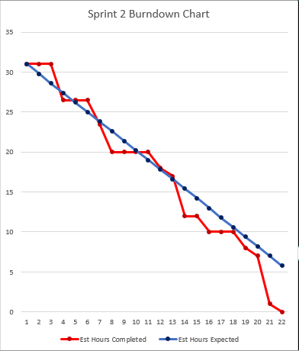

*Figure 1 – Sprint 2 Burndown Chart*

Group productivity was more consistent in sprint 2 than sprint 1. Illustrated in figure 1, *Est. Hours Completed* (red) kept in pace with *Est. Hours Expected* (blue), with the first task completed as early as day 3.

Three separate surges in task completion occurred during this sprint: first, search engine implementation [days 6-8], followed by user login and register [11-14] and then finally product testing [18-22]. The same ‘end of sprint’ spike in productivity occurred here as it did at the end of sprint 1. Because of this, *actual hrs completed* managed to outrun *expected hrs* during the last two weeks of development.

**What you did not do well?**

Despite sprint 2’s leap in productivity, communication issues remained. Minor discrepancies between commits caused page errors in the final product, especially when altering models.py. An example of one such discrepancy occurred later in the sprint [day 17]. This required an entire evening’s worth of time to fix, effectively doubling the est. hoursof all the stories and tasks that bug involved. These communication problems could have been fixed by holding more frequent SCRUM meetings. Instead, it seemed like both CS students were developing their own ‘halves’ of the project quasi-individually.

**What will you do differently next time to improve the performance of the team?**

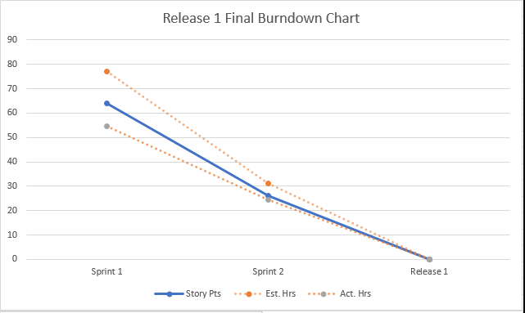

*Figure 2 – Release 1 Final burndown*

The idea behind sprint 2 was to assign the role of SCRUM master to one team member instead of cycling it on a weekly basis. This did not eventuate due to time constraints. However, overall productivity still managed to improve over the sprint. This was mainly because the CS students were becoming more familiar with Django, thus allowing tasks to be completed faster.

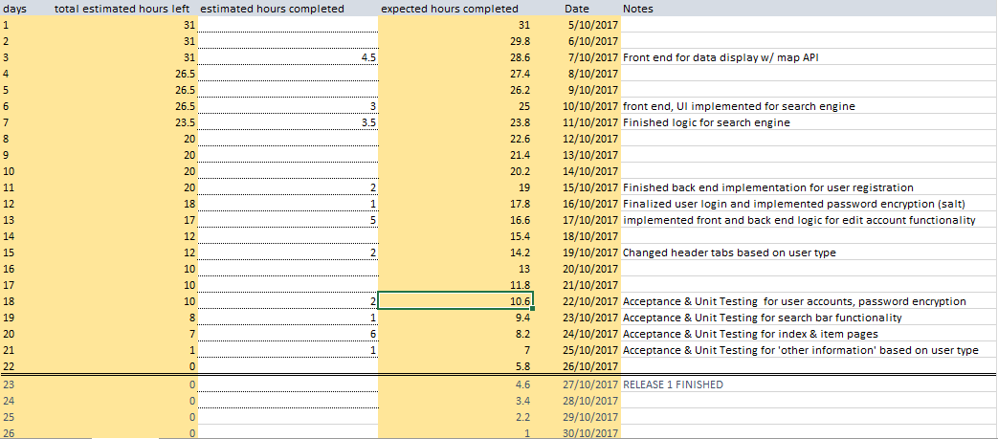

*Figure 3 – Sprint 2 Burndown by day*

This sprint would have benefited from more meeting minutes, as miscommunication seemed to be one of the group’s major stumbling blocks.